|  |  |  |  |  |  |
| --- | --- | --- | --- | --- | --- |
| Date | 6-Dec-22 | | | Tester Name | Mohammad Yusuf |
| Environment | Penfax - Test | | | Login used |  |
| Operating System | Windows | Version: | Update: | | |
| Software Used | Select Software | Version: | Update: | | |
| Select Software | Version: | Update: | | |
| Release version |  | | | | |
| Title |  | | | | |
| Test Type | Regression | | | | |
| Test Scenario |  | | | | |
|  |  | | | | |
| Expected Results |  | | | | |
| Pass/Fail | Select | | | JIRA# | N/A |

Describe your steps with screenshots:

Search a member using a Benefit Event Search

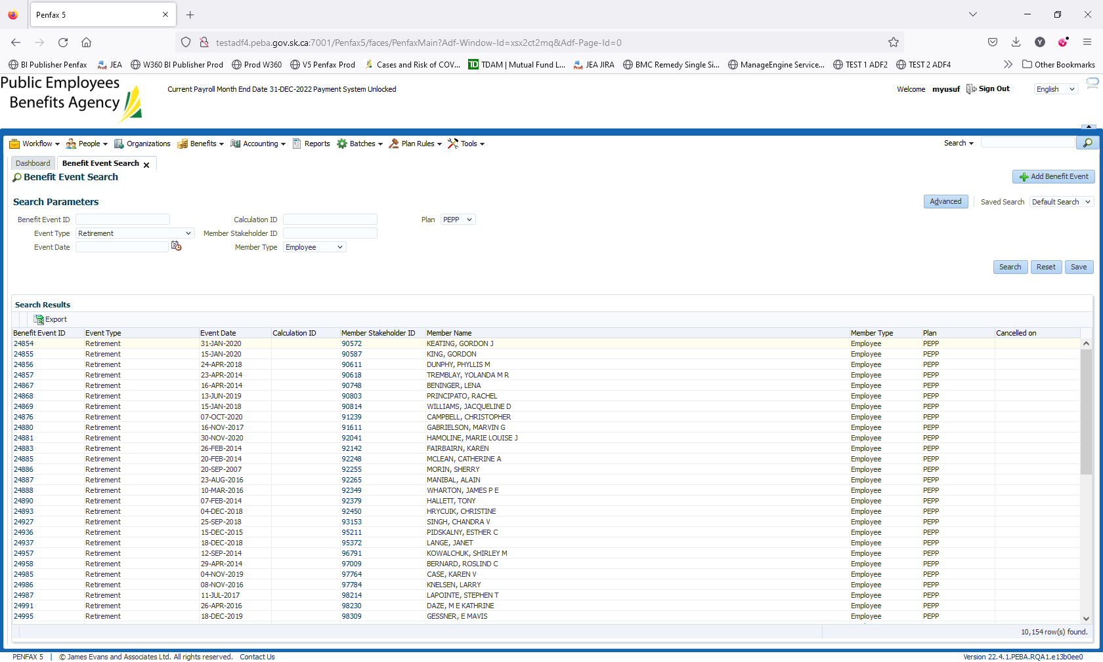

Select a member. Click on the Benefit Event ID. For example, 26783

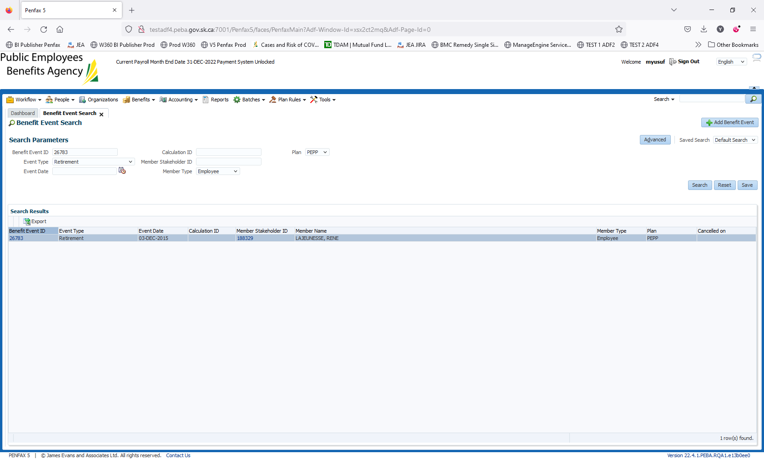

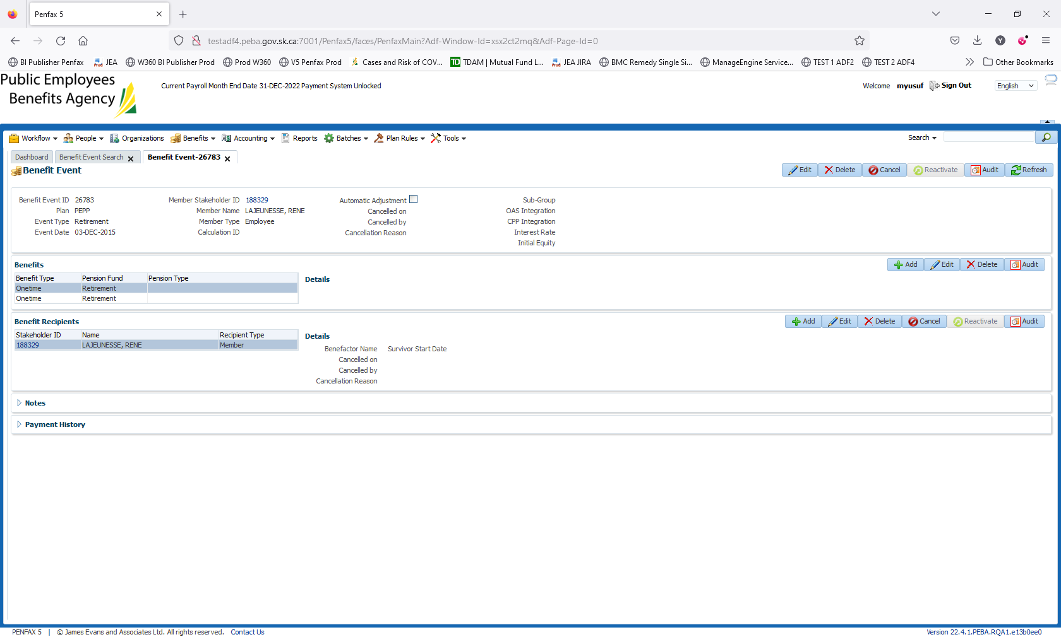

In Benefits, Click on Add. Add the mandatory details. Click Save

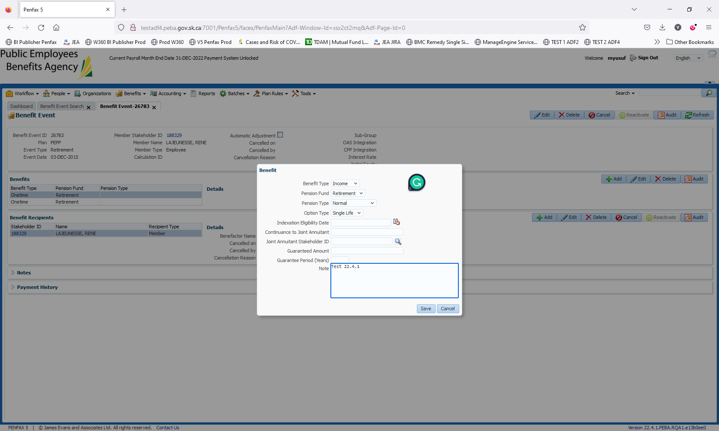

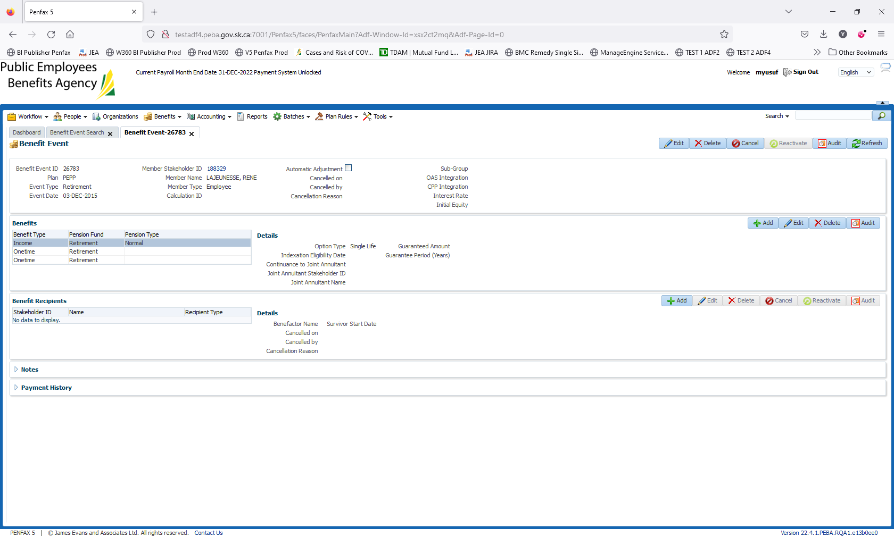

Go to Benefit Recipients. Click on Add.

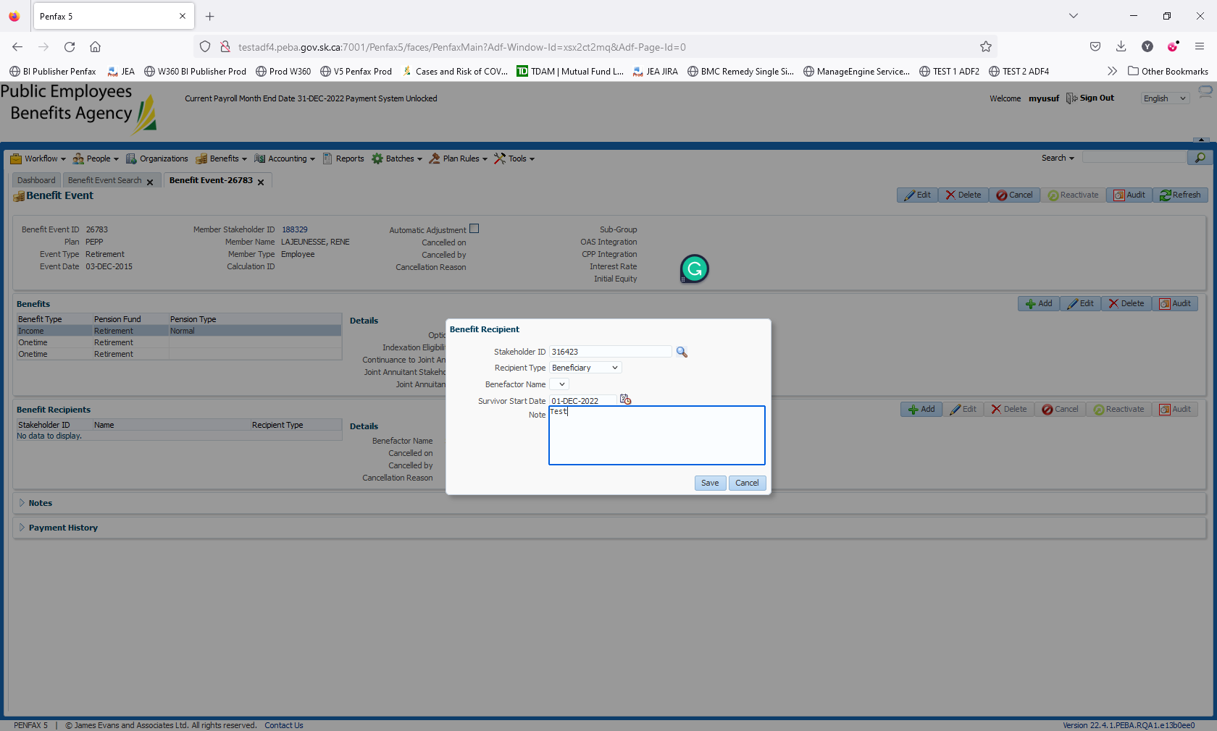

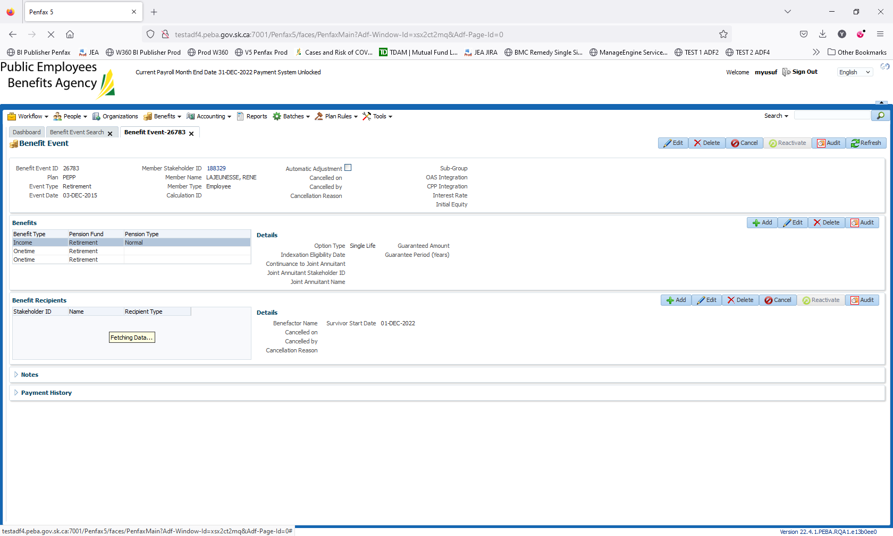

Click Save

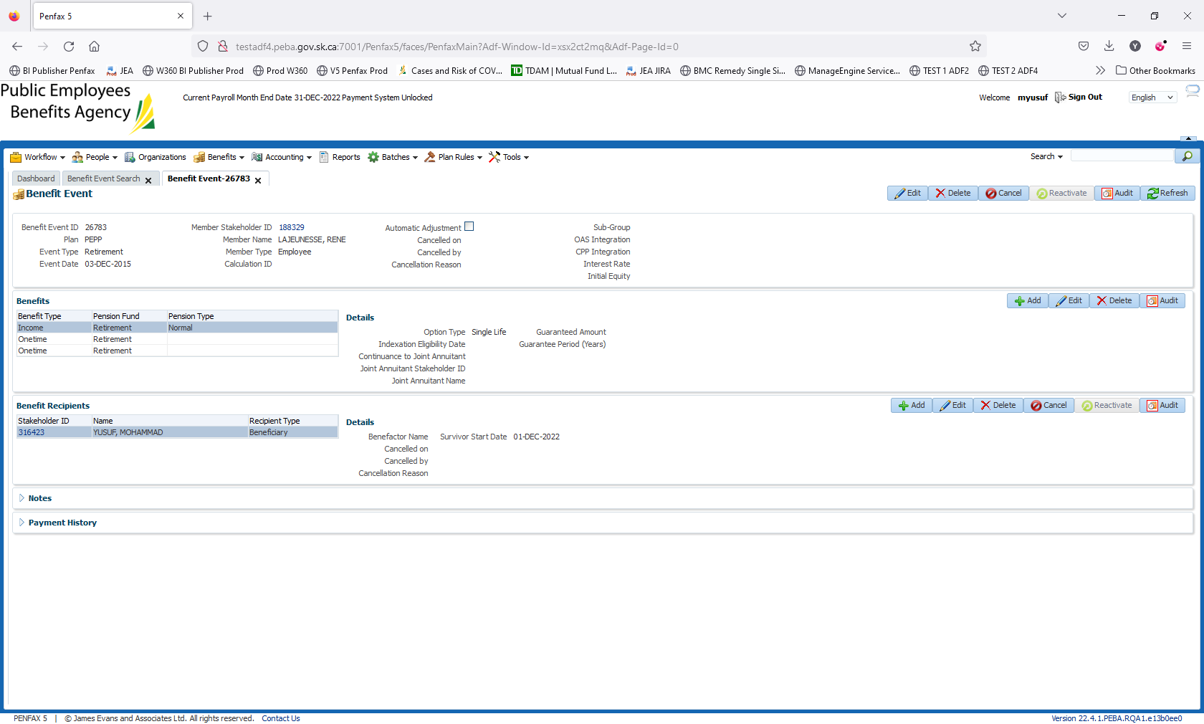

Go to Member (Stk ID 188329). Navigate to Benefit Recipient -> Income Amounts. Click On add.

Add Payment Instructions and

Add Tax Instructions

